**DATE:** 3/6/2013

**T0:** MARK KOCHANSKI

**FROM:** Paul Kwon

**TEAM MEMBERS:** Sohaib Hussain, Paul Kwon, Anthony Hopkins,

John-Paul Wallway

**SUBJECT:** TEAM IOBYTES STATUS REPORT: 2/27-3/6

**Project Status:** Percent Complete 35% (Project breakdown by percentage: Analysis 30%, Design 25%, Construction 30%, Testing and Deployment 30% - currently Analysis is complete, Design is at roughly 25% completion, will be complete when all use cases are accounted for).

The PM Meeting this week covered what we completed in the by the end of this current sprint cycle. Questions have been submitted to the design team. We have created a portfolio that is *not* final, and will improve over the course of the project. This cycle, we will be gathering and organizing all the works we have done so far in preparation for final portfolio submission.

# WORK PLANNED FOR LAST WEEK

* Complete portfolio with all web pages
* Adjust website design based off the results of the survey
* Come up with new questions for the next survey
* Have portfolio of artifacts with final designs of the 6 web pages

# WORK COMPLETED LAST WEEK – Encompassing Items from Backlog

* Adjusted website designs (still in progress – from backlog)
* Came up with new questions for next survey
* Completed portfolio (version 3 – from backlog)
* Assembled use case scenarios

# WORK PLANNED FOR NEXT WEEK AND BEYOND

* [Beyond] implement working prototype for website (estimated 5 hours of work per week)
* [Beyond] improve backlog configuration; make it easier to trace which backlog a task came from (estimated 2 hours of work)
* [Beyond] implement features from backlog (estimated 10 hours of work per week)
* [Beyond] run prototype testing (estimated 5 hours of work per week)
* [Beyond] implement changes from testing (estimated 10 hours of work per week)
* [Beyond] finalize changes, run acceptance testing (estimated 15 hours of work per week)

# IMMEDIATE TASKS

|  |  |  |  |  |  |
| --- | --- | --- | --- | --- | --- |
| Tasks | Planned | Forecasted | Actual | Status | Cost (in hours), for this week |
| Complete portfolio (version |  |  |  |  |  |
| 3) | (2/13/13) | (3/13/13) | N/A | Begun | 12 hours |
| Complete Use cases | (2/20/13) | (2/28/13) | 2/27/2013 | Done | 2 hour |
| Come up with new |  |  |  |  |  |
| questions for next survey | (2/10/13) | (2/20/13) | 3/6/13 | Begun | .5 hour |

Resources to be used in tasks: surveys, use case modeling software (possibly simple graphical image manipulation software), computers for communication, manpower (team BetaBytes).

# PROJECT BACKLOG – Remove when ready to put into work to be completed per week lists

DESIGN – 1 is highest priority

1. Send out final or incremental portfolios
2. Finalize mockups for UI
3. Finalize all use cases
4. Create activity diagrams

FUNCTIONALITY – Not prioritized

* Implement database client library
* Implement database interactions (from Database team) o Implement peer review updating feature o Implement new class creation tool (instructor) o Implement student score reviewing query o Implement students in group query o Implement students in team query
* Implement app download feature, for mobile o Add to mockups
  + Implement actual download feature
* Update UIs to include user functionality explanations
* Implement iOS/Android compatibility views
* Implement site plug-in with Canvas and other LMS
* Implement standalone site for unhindered usage
* Implement custom criteria creation tool
* Implement and ensure compatibility with most known and most used browserso Chromeo Safario Opera
  + IE (10, and the rest)o Firefox
* Implement Database update functionality

# ARTIFACTS

Versions 1.0 of Artifacts

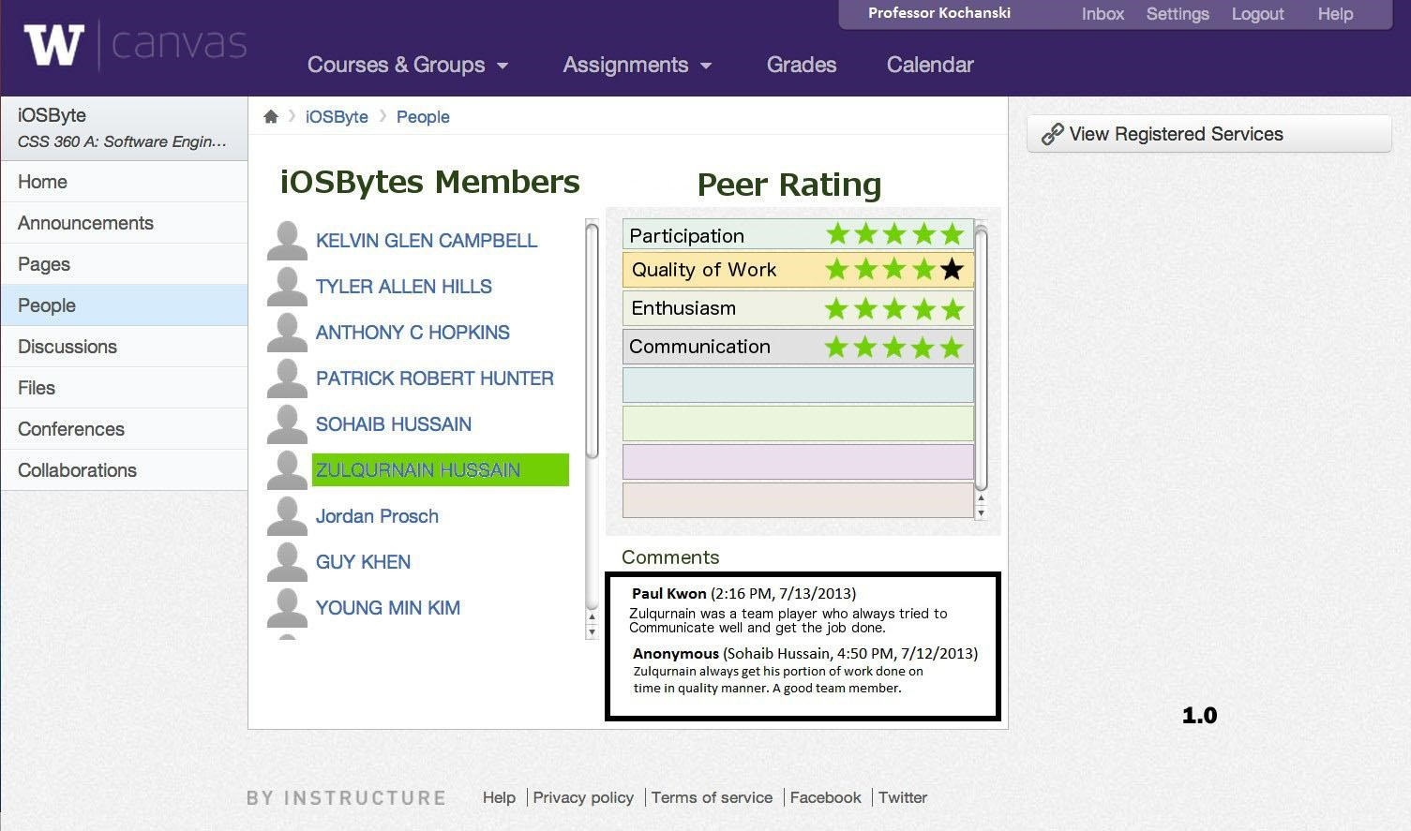

The picture above is an instructor view of the peer review page, version 1.0. The instructor can see each student’s work (via communication with the database, in construction and maintenance by the database team) for the peer rating retrievals, as well as the comments. 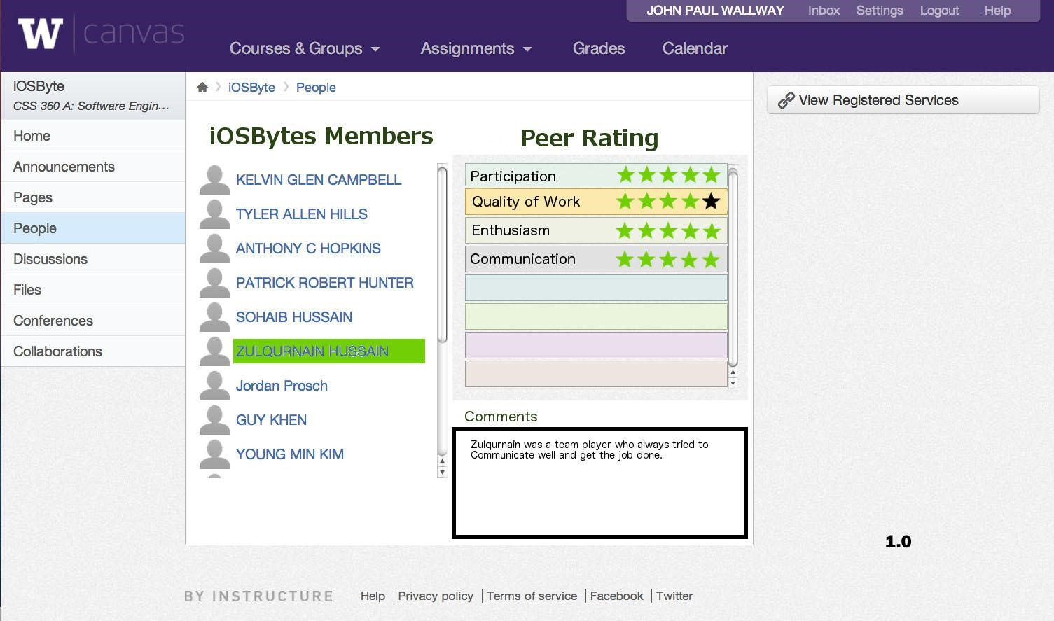

The picture above is a student view of other team members, version 1.0. The main difference between this and the previous picture is that you can only view your own comments, rather than everyone’s. Again, by clicking on a name, the website fetches information via the database (courtesy the database team).

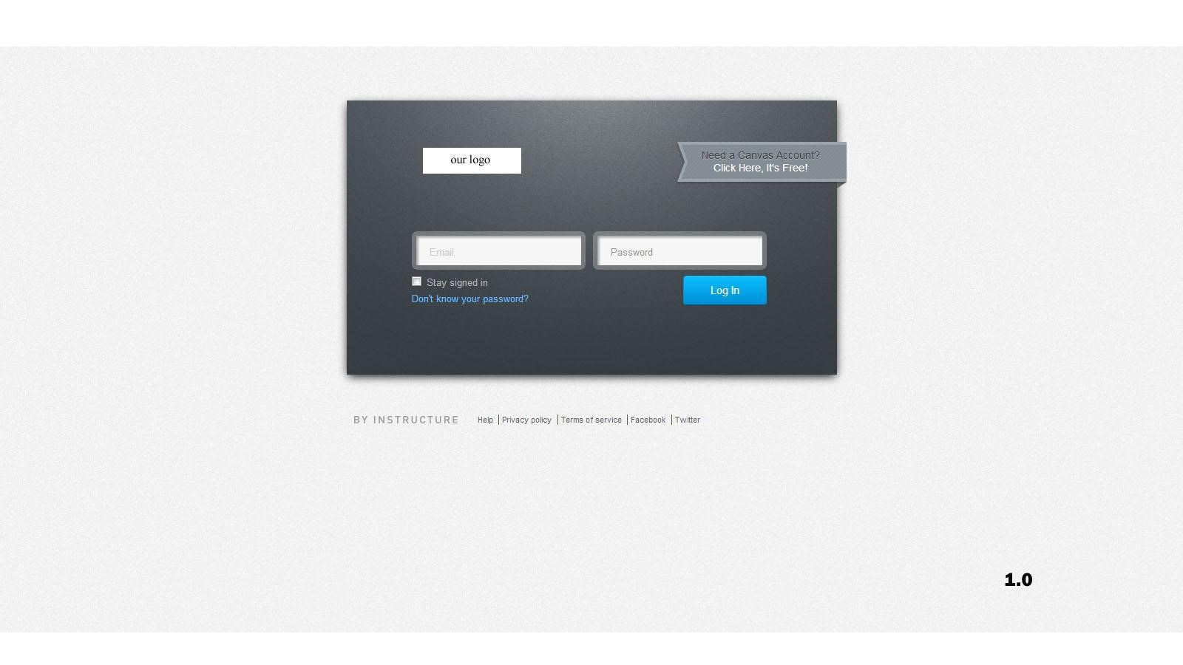

Above is version 1.0 of the login page. It would use Canvas’ login, if that is what most instructors prefer. From here, you can login to your generic instructor/student homepage.

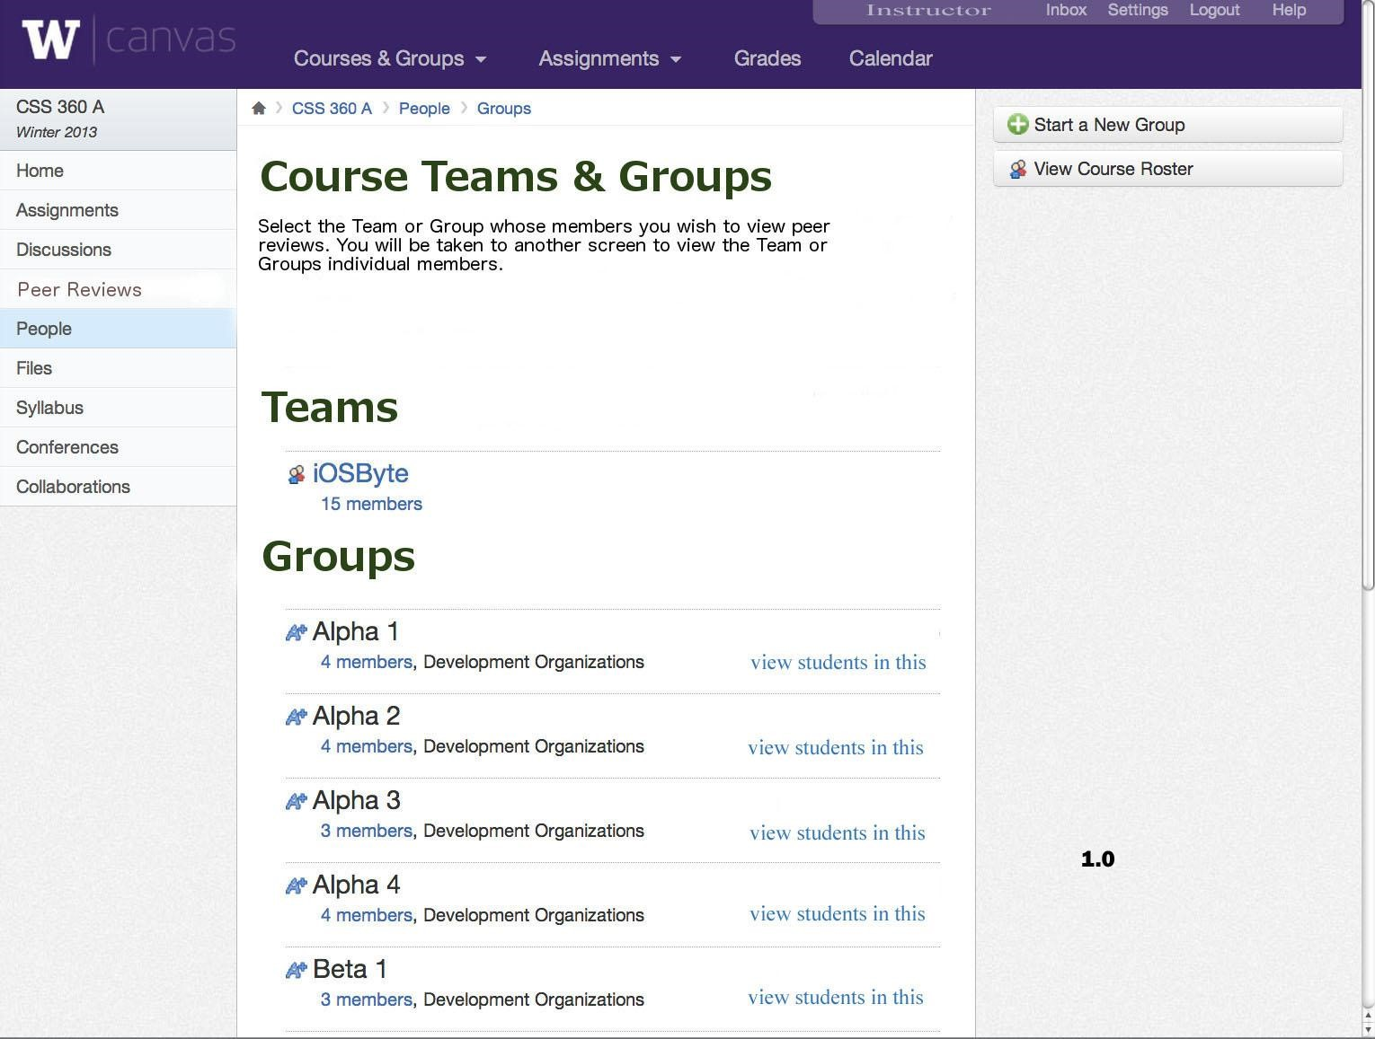

This snapshot shows the generic instructor homepage for a specific class (version 1.0). From here, the instructor can click on and view any team, and any of its members, including all of their reviews and ratings, complete with who wrote them.

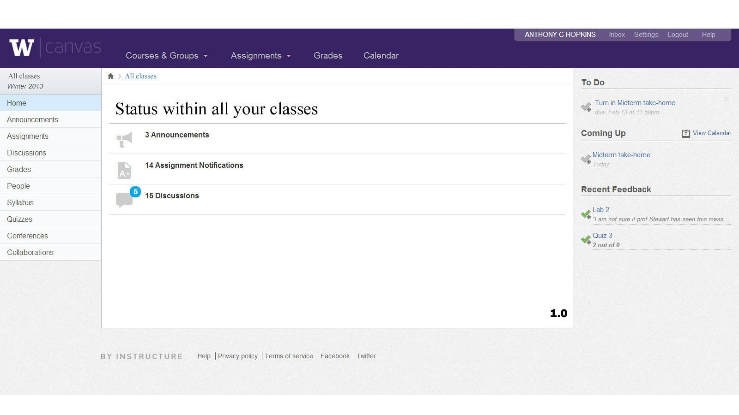

Above is a generic student page, version 1.0. From here, you can navigate your course via the sidebar on the left, or the options in the middle.

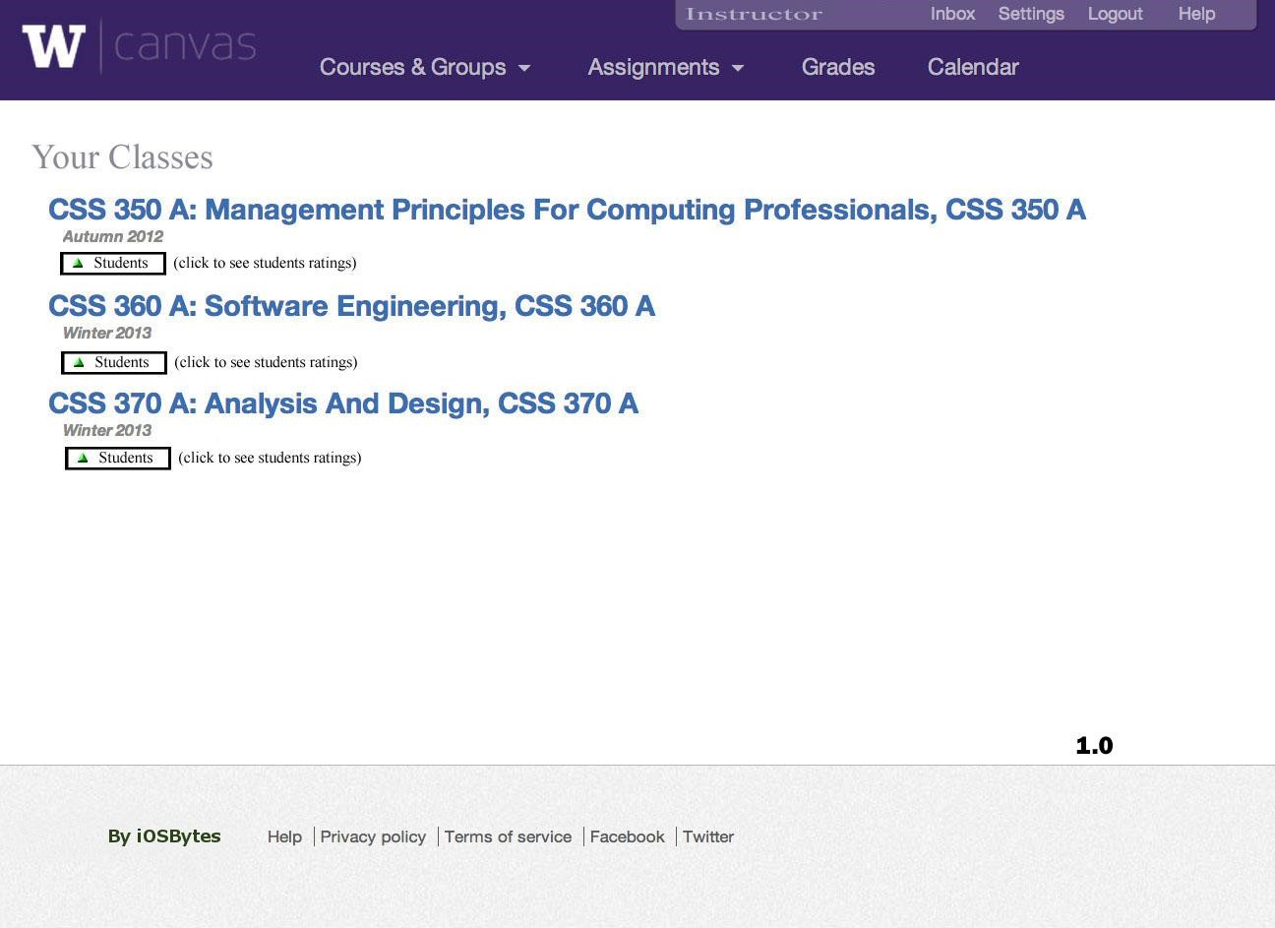

Generic instructor homepage (version 1.0). From here, an instructor can immediately navigate to students, or they can navigate to any specific course from here.

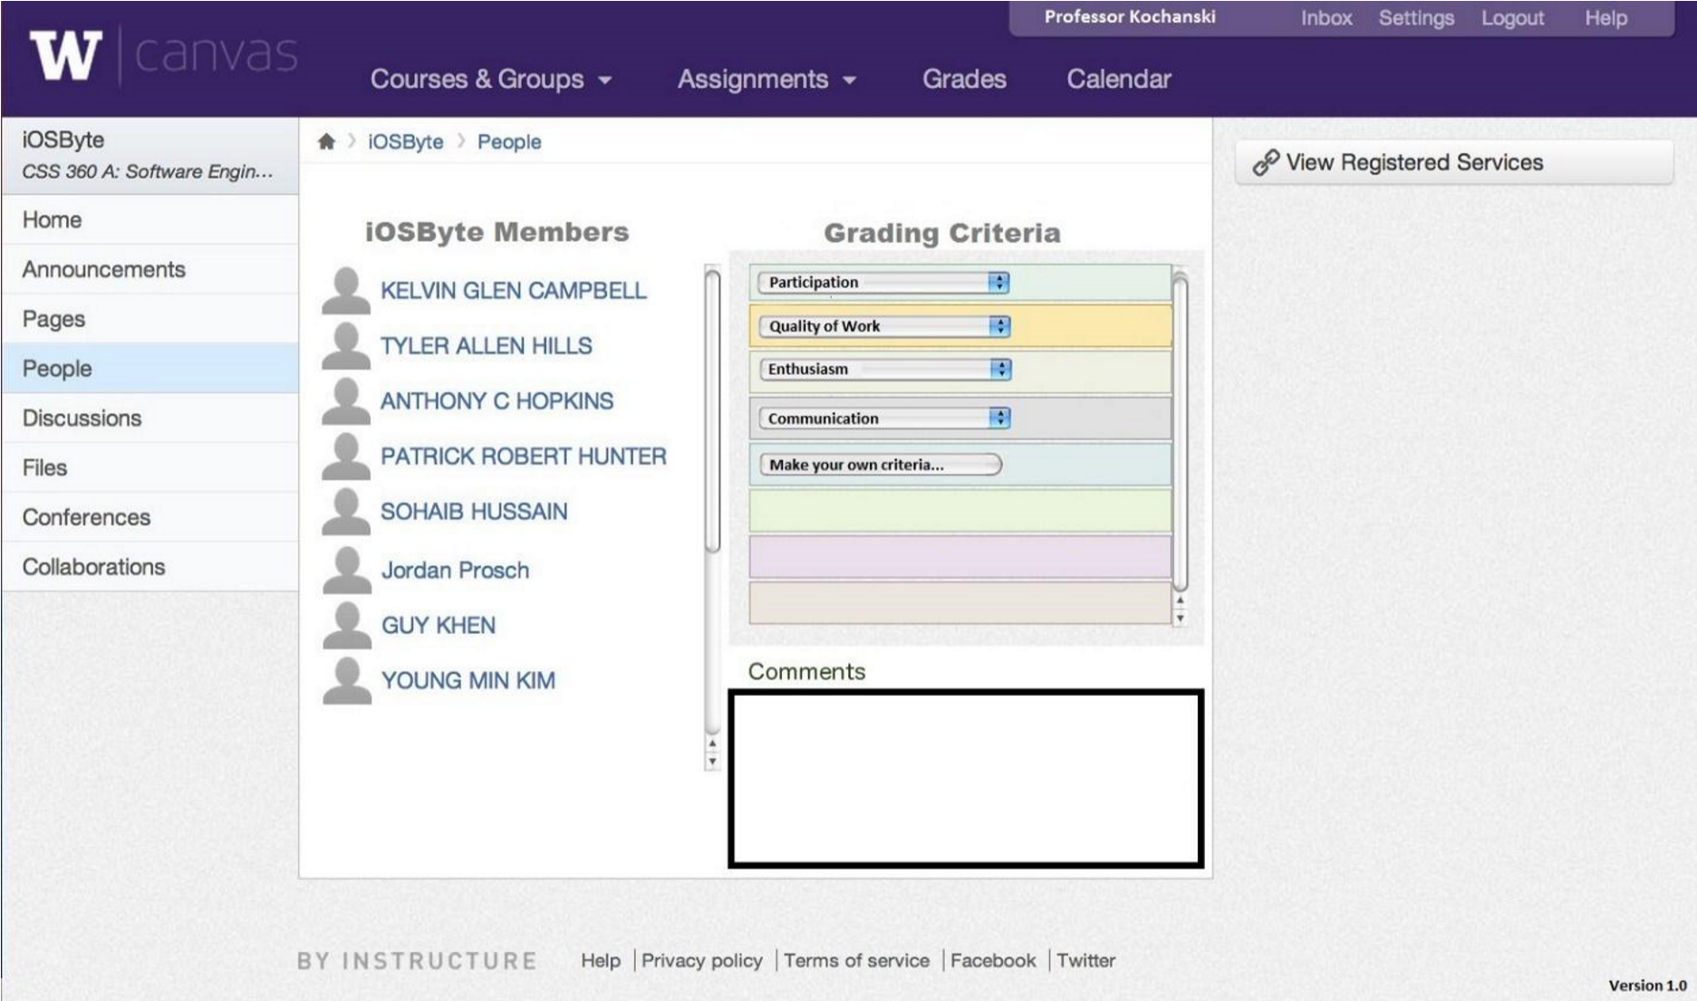

Generic instructor peer review creation page (version 1.0). From here, the instructor can create his own custom grading criteria (the list box in the middle of the page with participation, quality of work, etc). He can still view the students in the group/class/company from here (the list of hotlinked names on the left side), and navigate to other parts of his site (the nav bar on the left).

Updated Versions

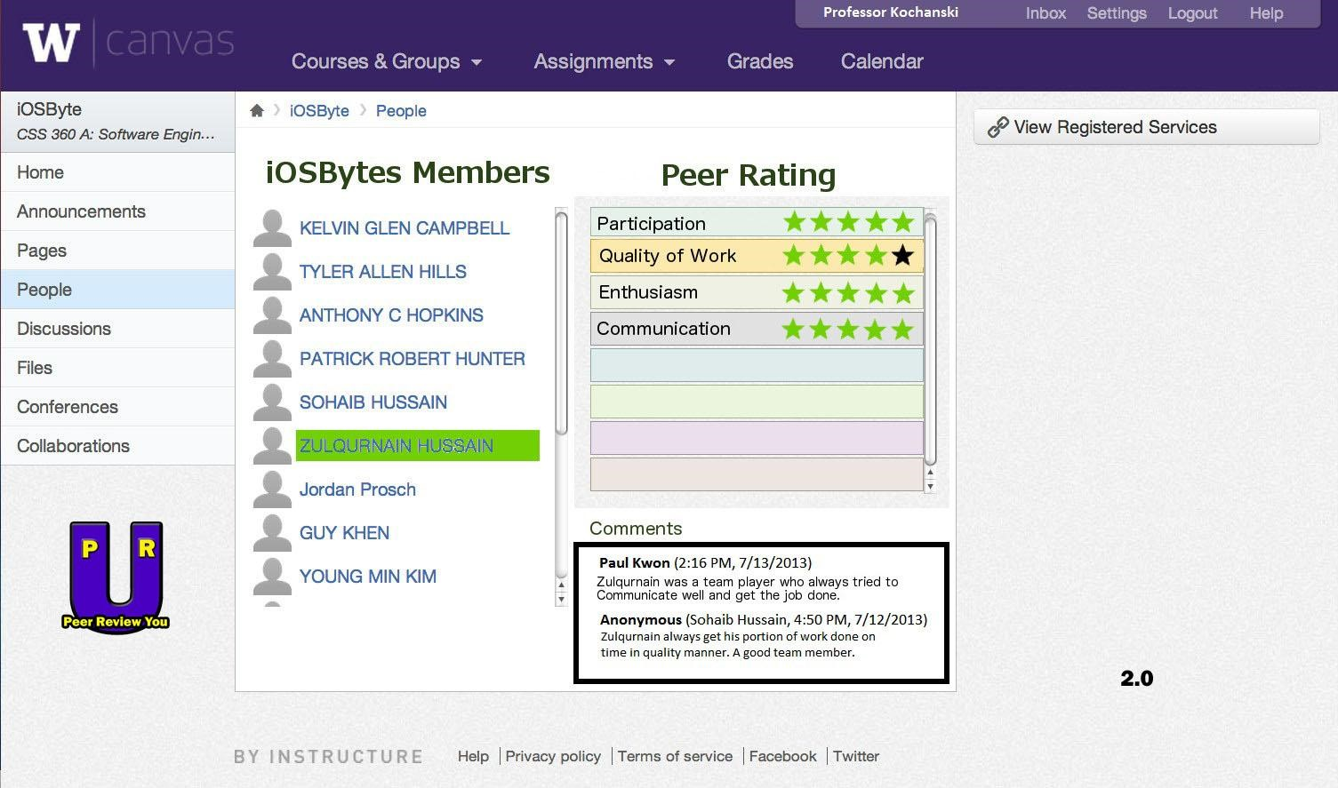

Professor page for a team (version 2.0). Difference between 1.0 and 2.0: added company logo to bottom left.

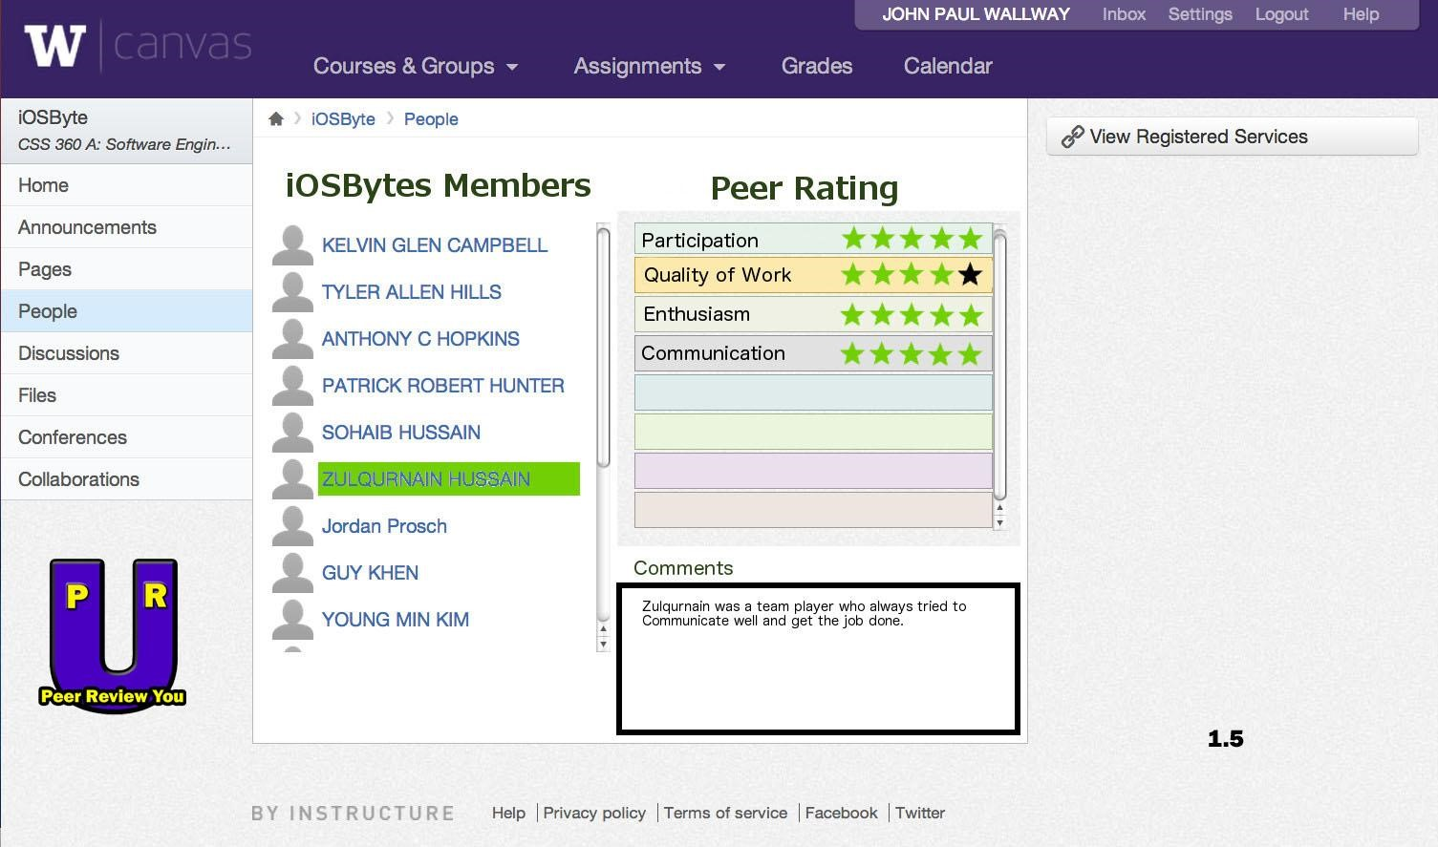

Student team page (version 1.5). Differences between 1.0 and 1.5: added company logo to bottom left.

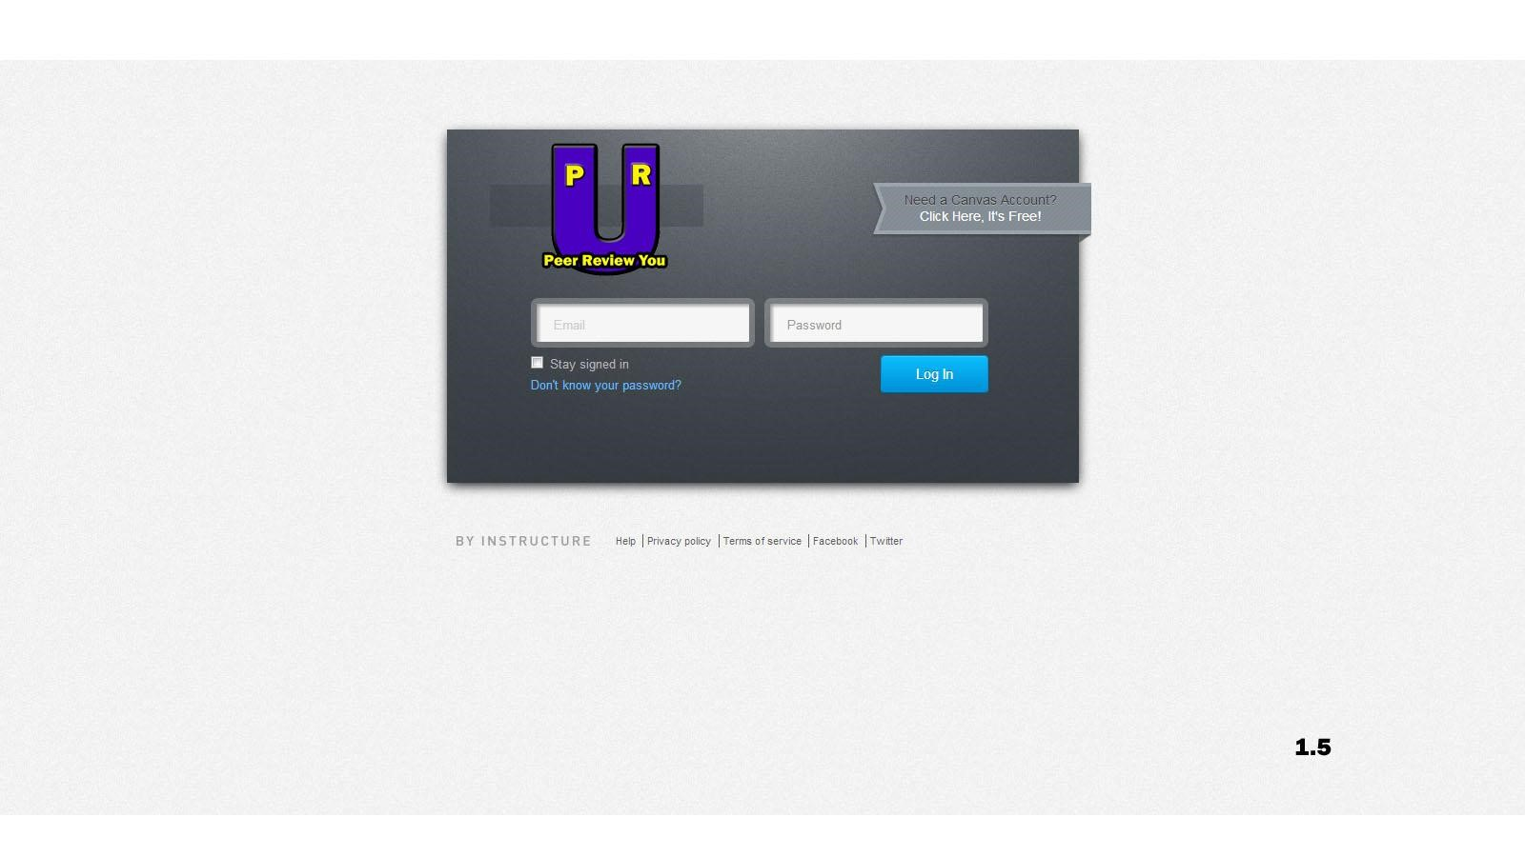

Generic login page (version 1.5). Differences between 1.0 and 1.5: added company logo to top left.

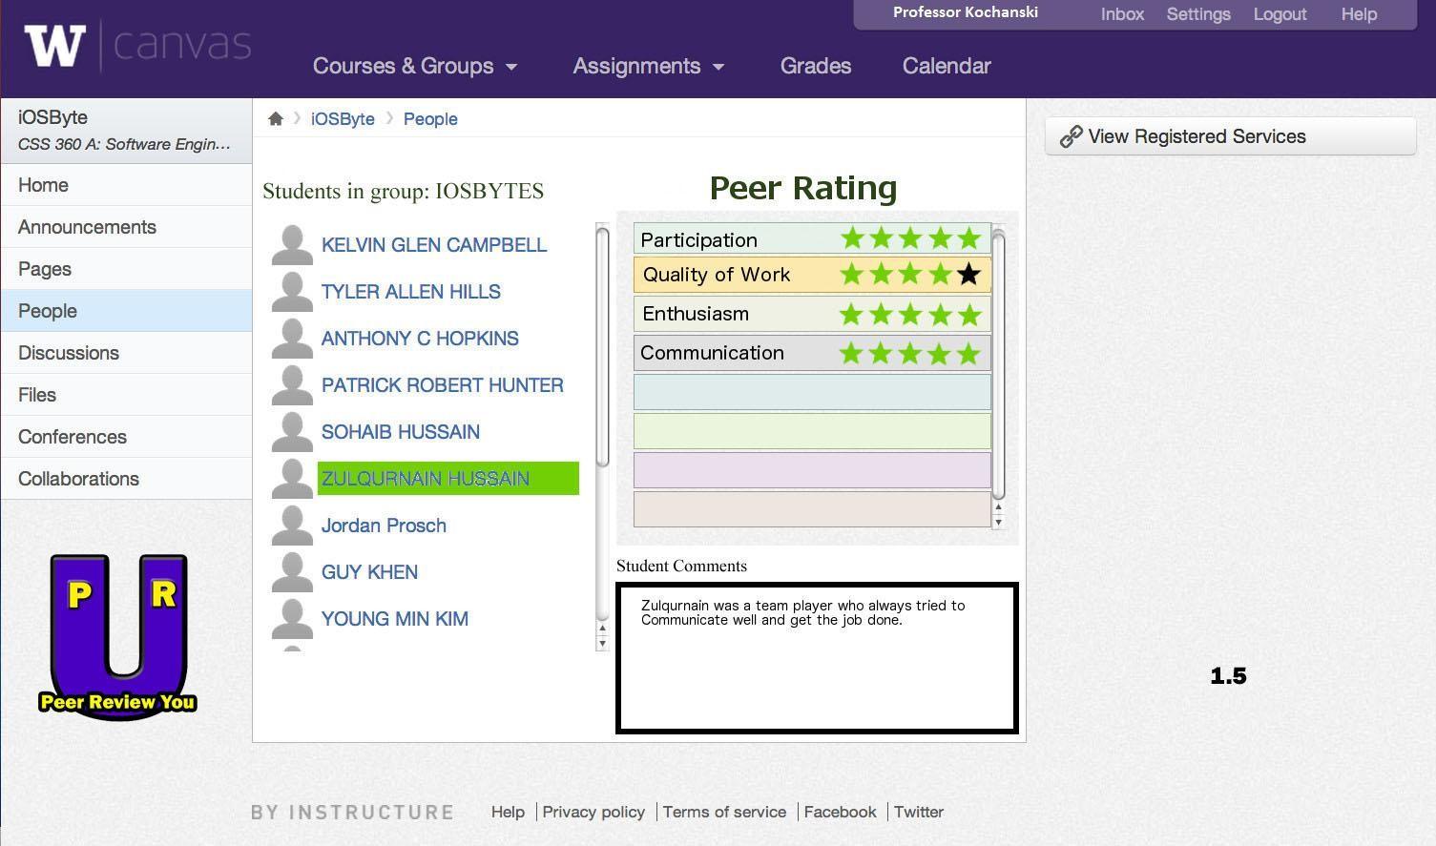

Generic instructor page (version 1.5). Differences between 1.0 and 1.5: added company logo to bottom left.

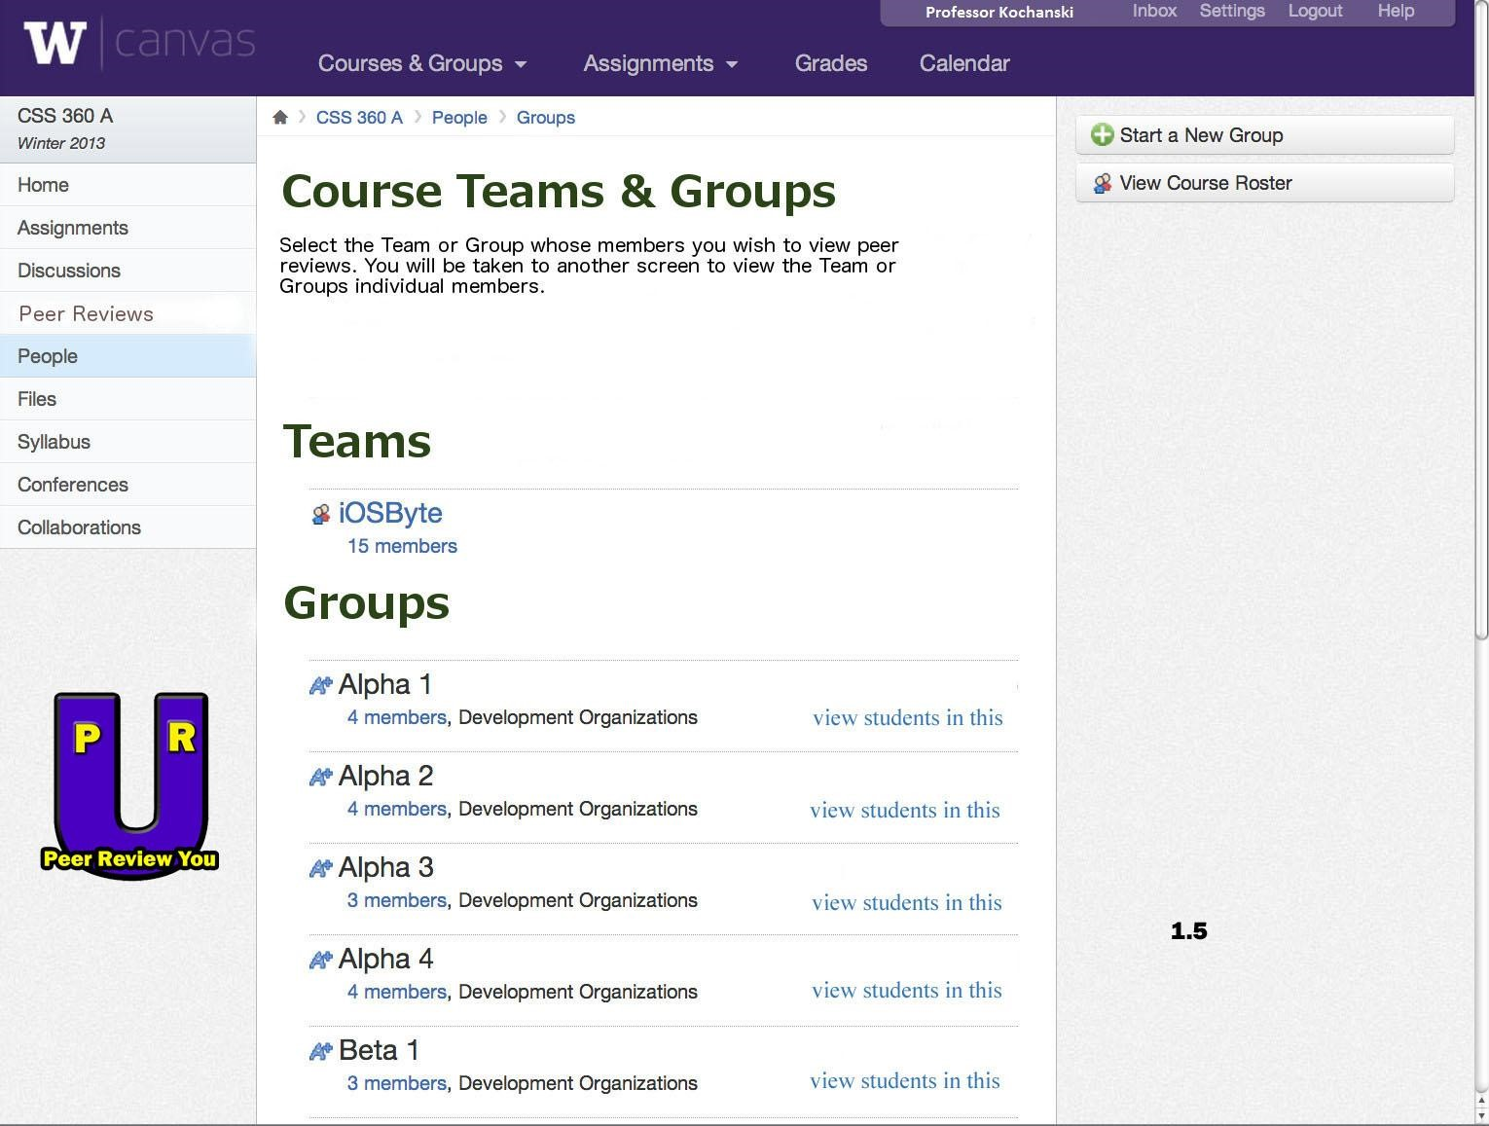

Generic instructor course page for peer reviewing (version 1.5). Differences between 1.0 and 1.5: added logo to bottom left.

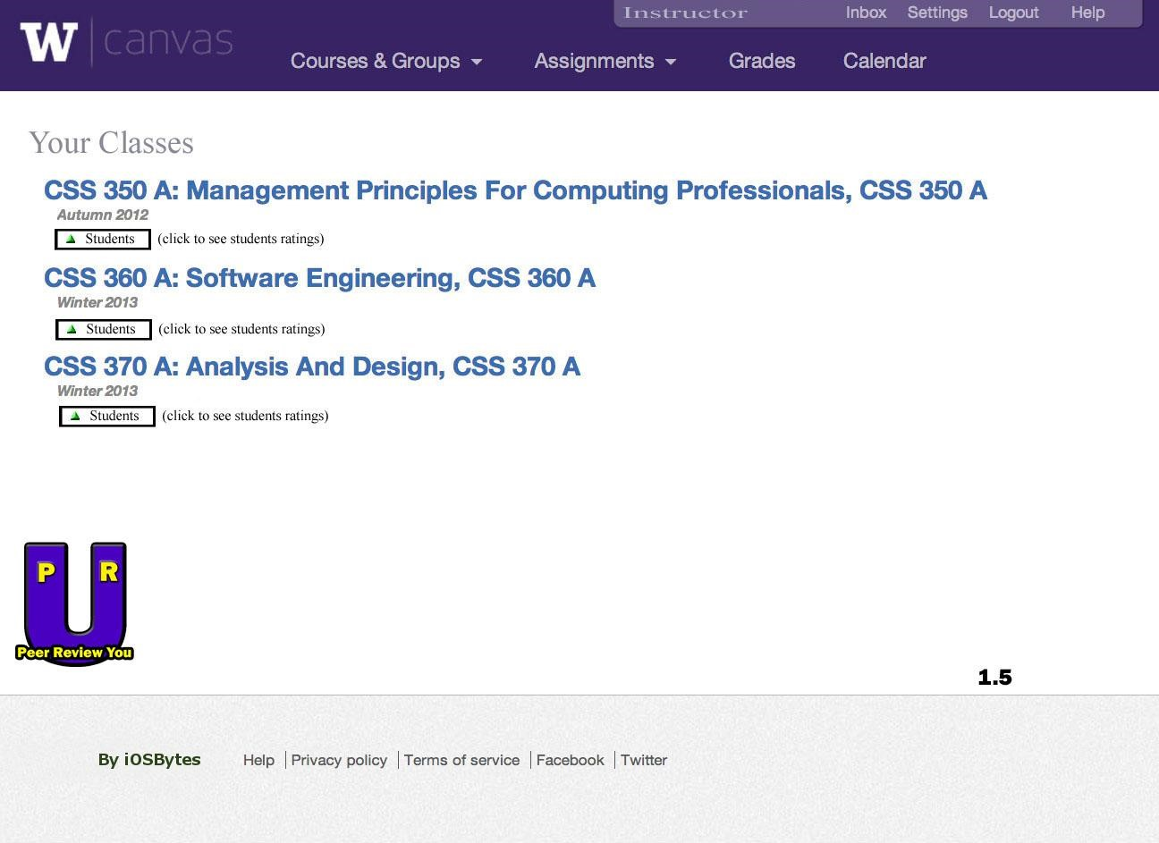

Generic instructor homepage (version 1.5). Differences between 1.0 and 1.5: added logo to bottom left.

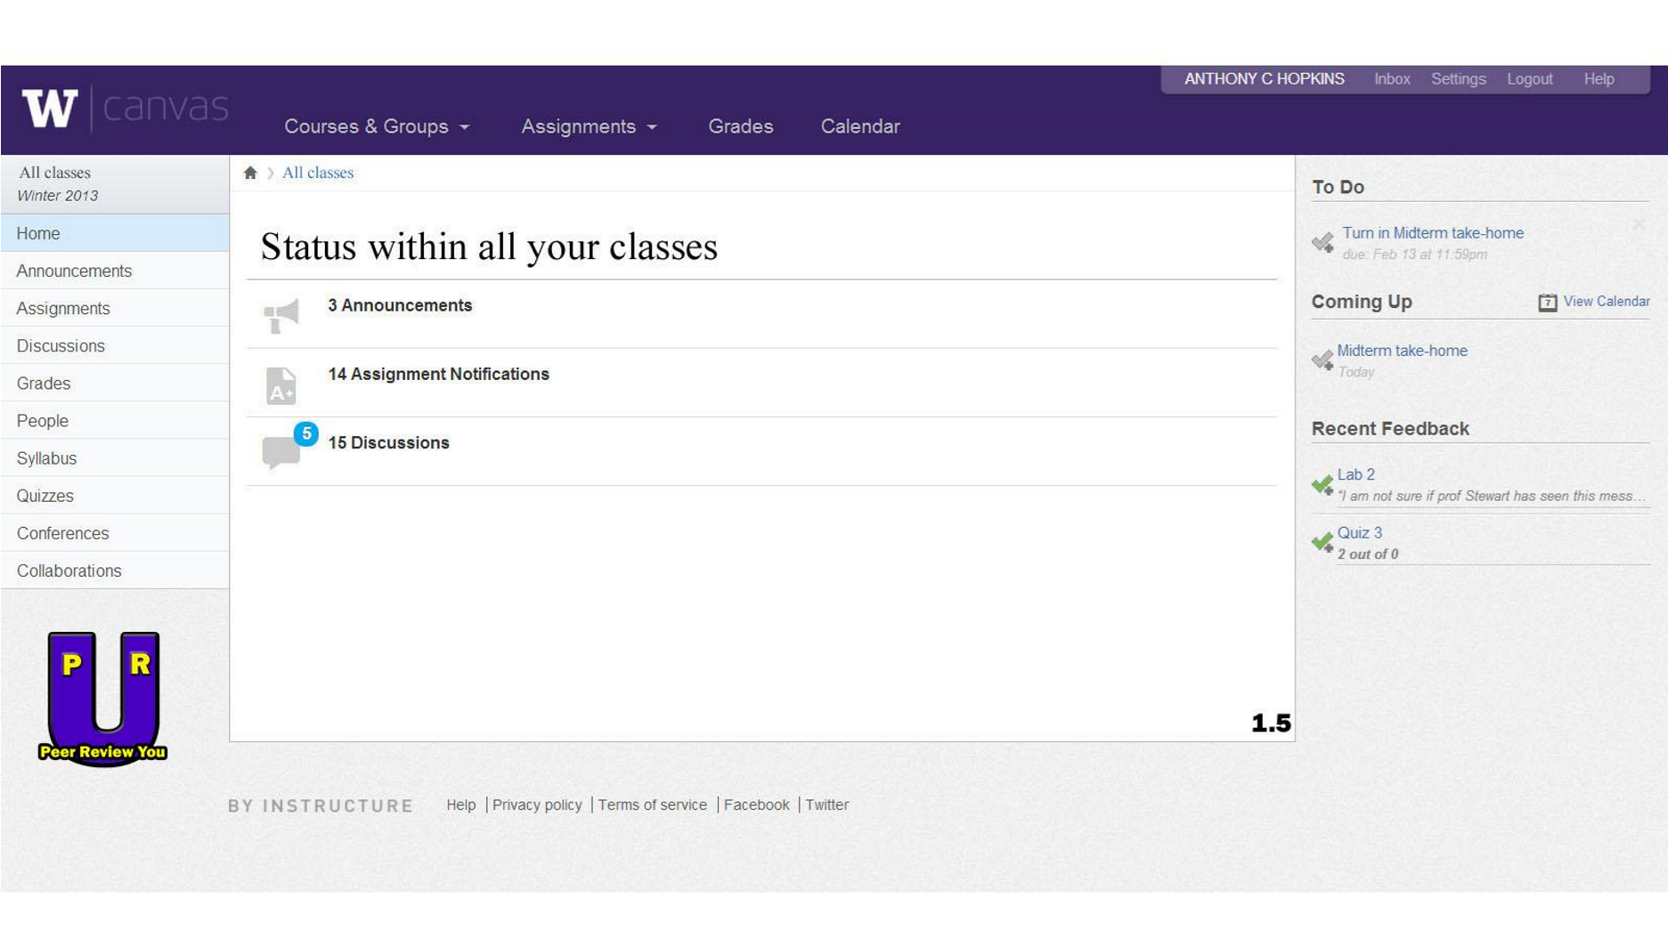

Generic student homepage (version 1.5). Differences between 1.0 and 1.5: added logo to bottom left.



Generic student homepage (version 1.5). Differences between 1.0 and 1.5: added company logo.

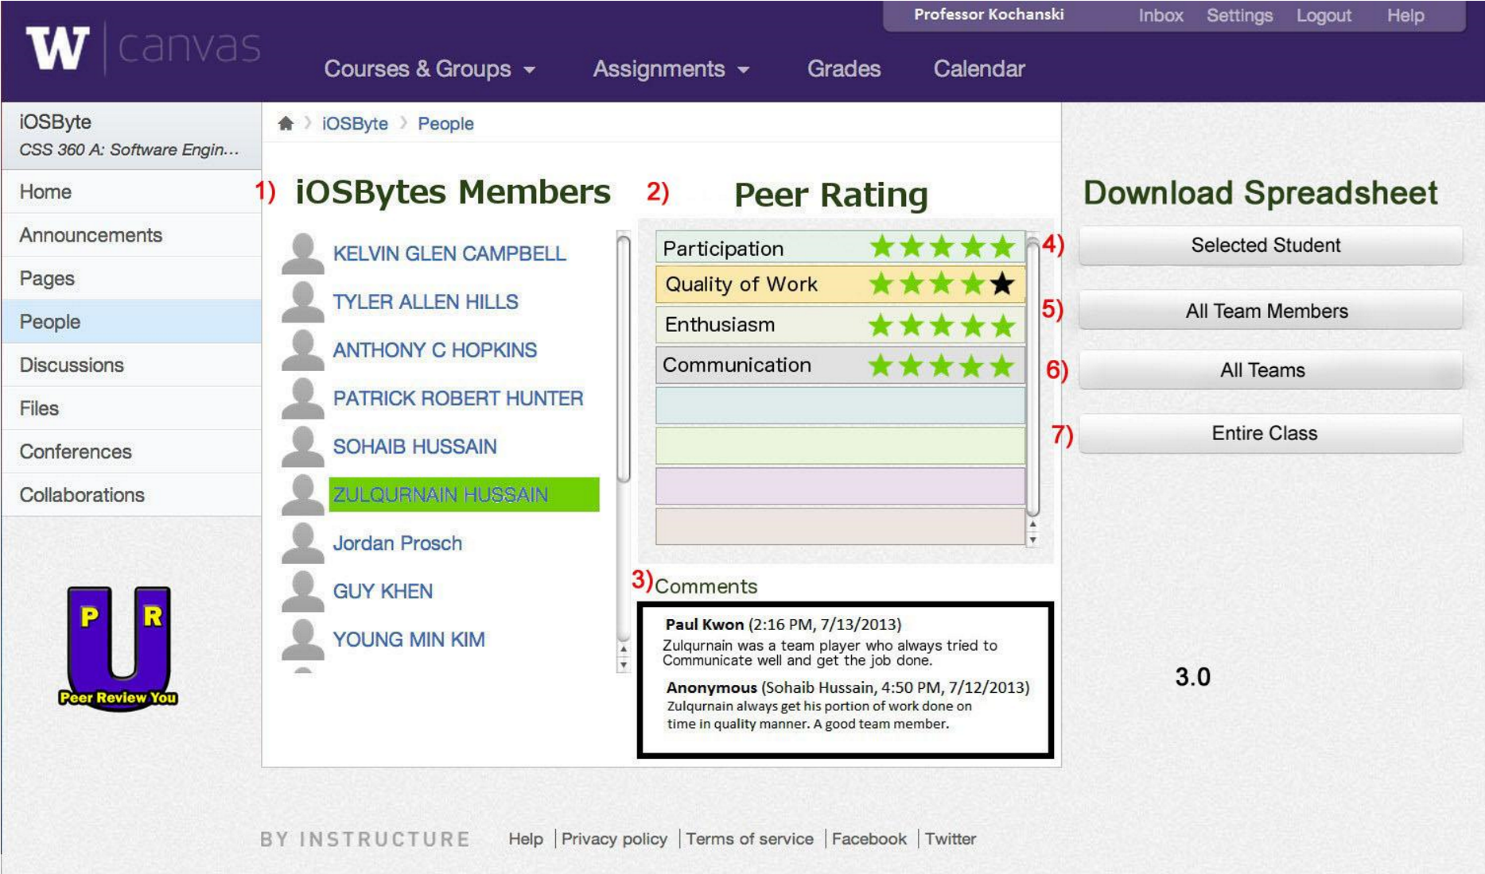

1. List of group members
2. Peer rating panel
3. Comment panel
4. Download spreadsheet version of selected student’s rating
5. Download spreadsheet version of all team members’ rating
6. Download spreadsheet version of all teams’ rating
7. Download spreadsheet version of entire class’s rating

Generic instructor page (version 2.0). Differences between 2.0 and 3.0: added descriptions for numbered items; added a feature that allows instructor to download spreadsheet versions of ratings.

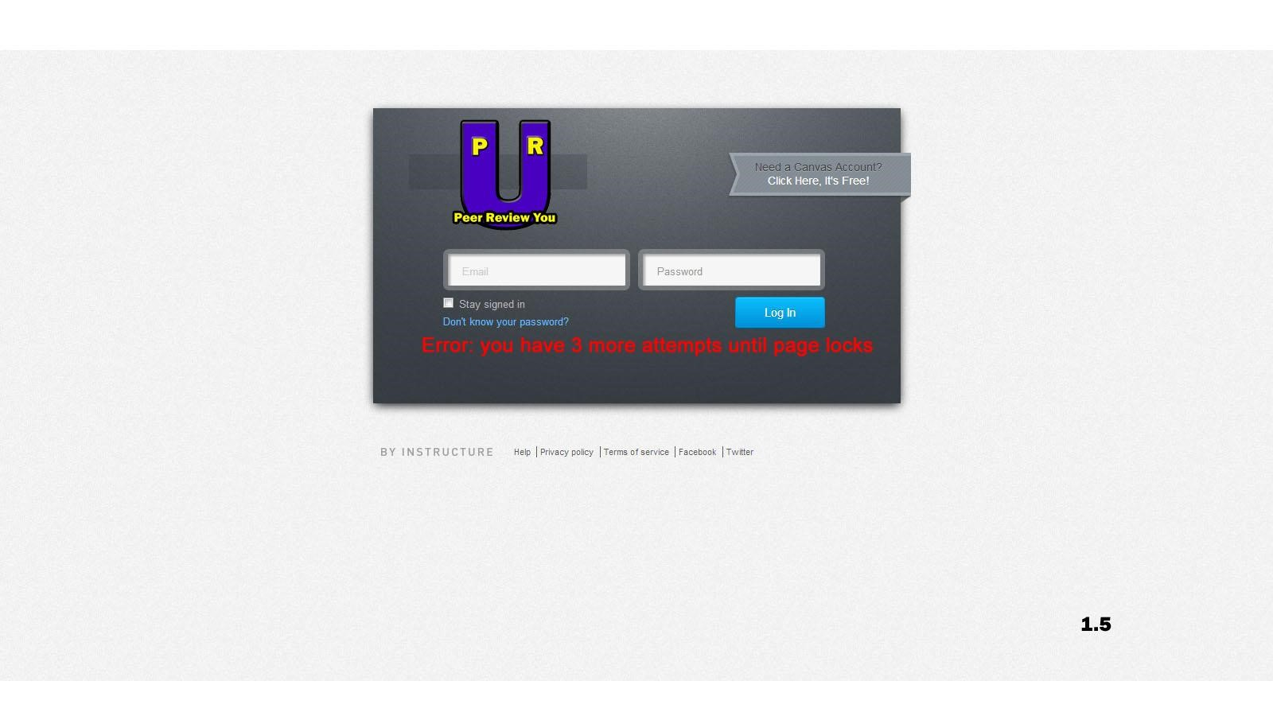

Generic login page (version 1.5). Differences between 1.0 and 1.5:added a warning message that pops when user types in incorrect password for 5 instances.

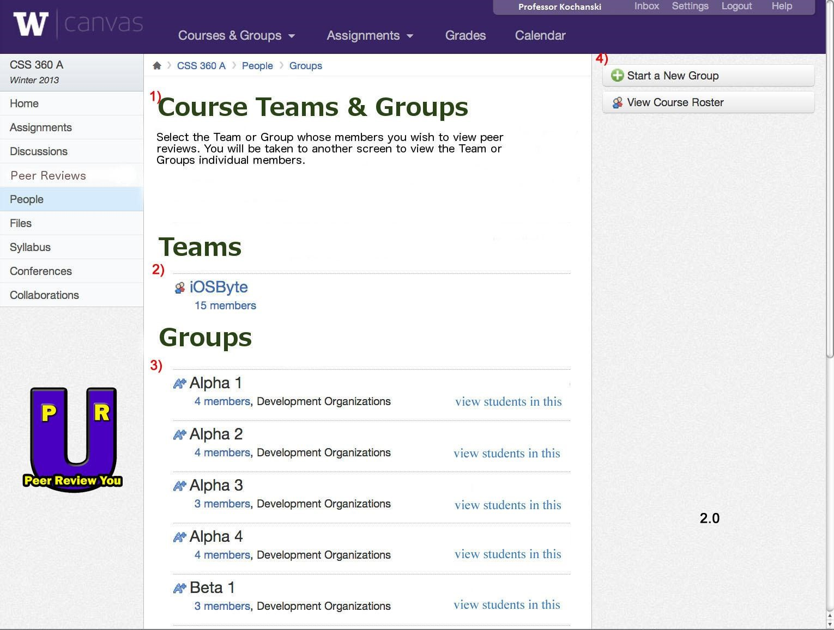

1. List of menus
2. List of teams
3. List of groups of selected team
4. Creates a new group into existing team

Generic instructor course page for peer reviewing (version 1.5). Differences between 1.0 and 1.5: added descriptions for the numbered items.

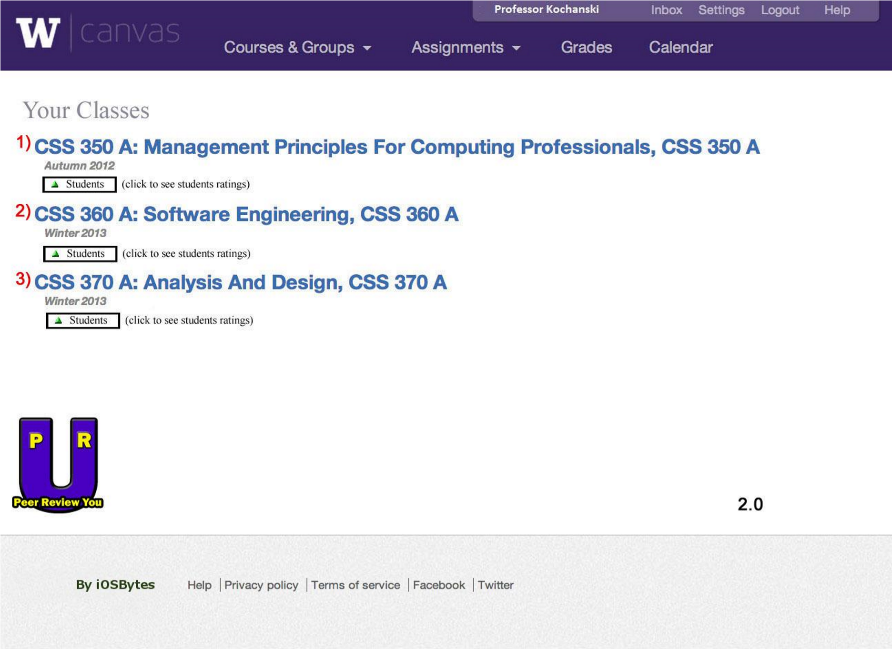

1) ~ 3) List of courses taught organized in chronological order (oldest being at the top)

Generic instructor homepage (version 2.0). Differences between 1.5 and 2.0: added descriptions for numbered items.

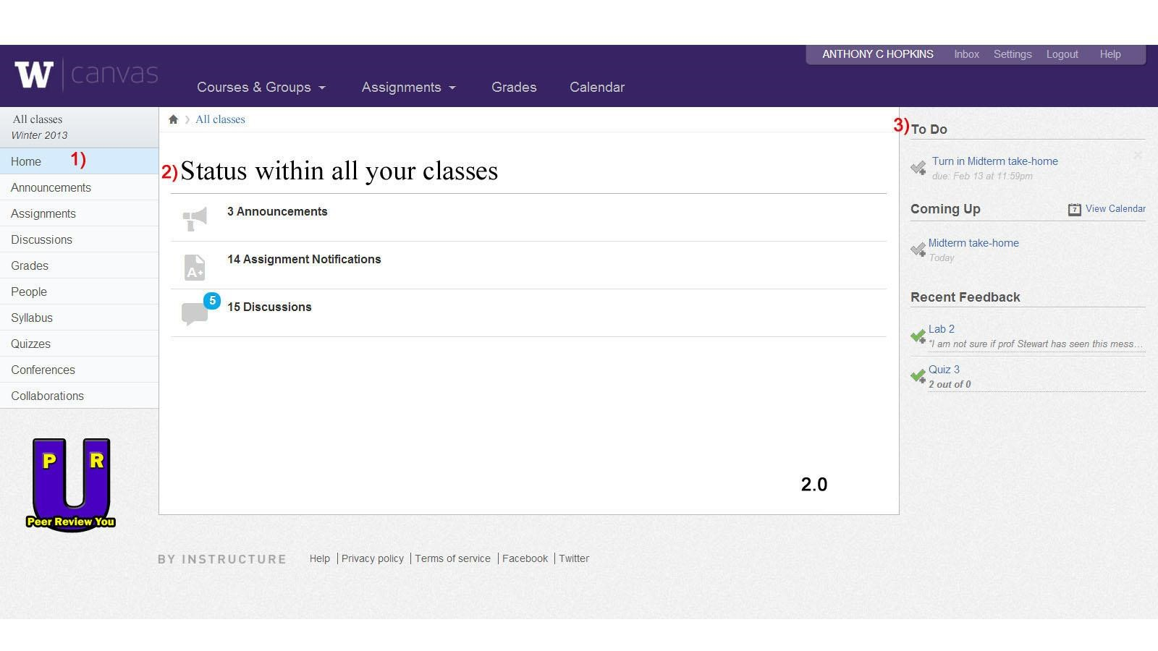

* 1. List of menus
  2. List new updated statues from all of your classes
  3. List of assignments that are due soon

Generic student homepage (version 2.0). Differences between 1.5 and 2.0: added descriptions for numbered items.

# Databases To Use (courtesy Database team):

Database Tables

Prepared by Guy Khen and Travis Olson

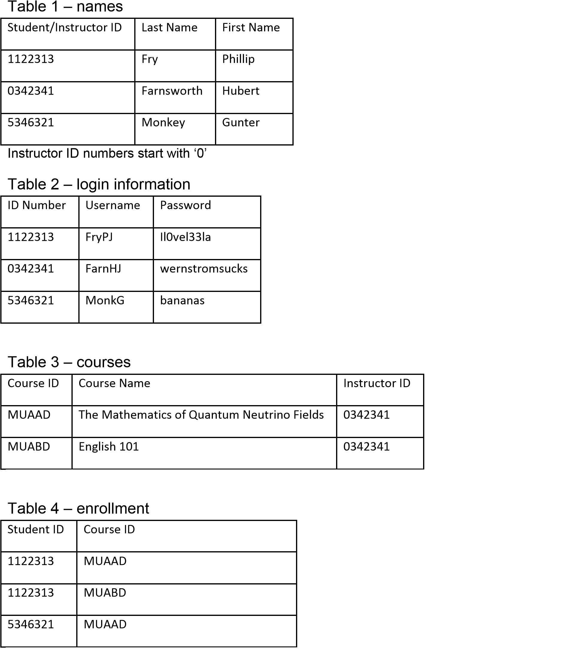

Table 6 – comment information

Table 5

–

comments

Comment ID

Content

Content

6365324

“Jerk”

0

“Content” includes whatever we decide goes in there

–

comment, rating out of 10, whatever

|  |  |  |  |  |
| --- | --- | --- | --- | --- |
| Comment ID | Giver ID | Receiver ID | Course ID | Date |
| 6365324 | 1122313 | 5346321 | MUADD | 21/5/3001 |

# USE CASES

**LIST OF CASES CURRENTLY CREATED**

Instructor creates Peer Review Form

Student rates a peer 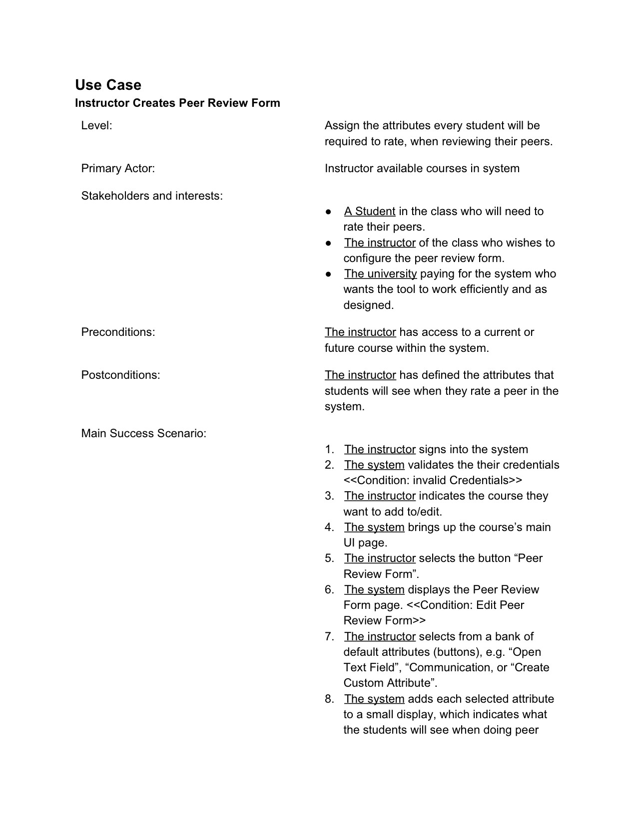

**Use Case**

Student uses website to rate peers

* **Level:** Assigns values to other students based off the rating system and rating options available• **Primary Actor:** Student utilizing the rating system• **Stakeholders and Interests**:
* A student utilizing the system
* An instructor wishing to see his/her student’s ratings
* The university wishing to use the system via payment
* **Preconditions:** A student has access to the website
* **Postconditions:** A student knows who they wants to rate, and how they wants to rate them• **Main Success Scenario:** 
  1. The student signs in to the system
  2. The system validates credentials of student
  3. The student navigates to the peer review system page (in LMS or separate site)
  4. The system updates the page the student has gone to by communication to the database
  5. The student selects a team member to peer review
  6. The student rates the peer with the given criteria(s)
  7. The system relays that information to the database, updating the current info on the students